Fase
Torredemer
2026-05-18
library(readr)
## Warning: package 'readr' was built under R version 4.2.3
DB_ea_sports24_preprocessing <- read.csv(
"C:/Users/Paco/Documents/TFM/bases_de_datos/DB_ea_sports24_preprocessing.csv",
sep = ";"
)
fifa_pre <- DB_ea_sports24_preprocessing
#VARIABLES NUMÉRICAS
#league_id
hist(fifa_pre$league_id)
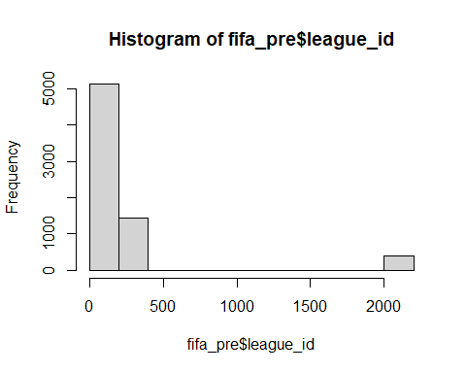
summary(fifa_pre$league_id)
## Min. 1st Qu. Median Mean 3rd Qu. Max.
## 1.0 20.0 60.0 216.7 308.0 2149.0
#overall
hist(fifa_pre$overall)
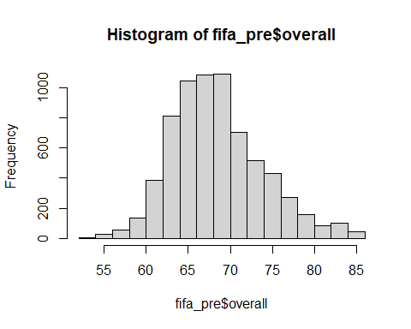
summary(fifa_pre$overall)
## Min. 1st Qu. Median Mean 3rd Qu. Max.
## 52.00 65.00 68.00 68.94 72.00 86.00
#attack
hist(fifa_pre$attack)
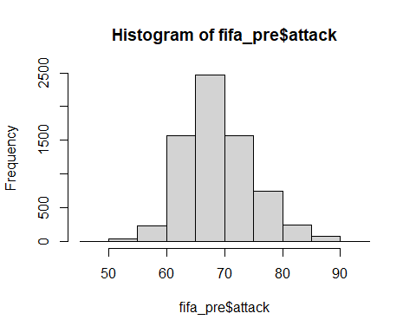
summary(fifa_pre$attack)
## Min. 1st Qu. Median Mean 3rd Qu. Max.
## 48.00 65.00 69.00 69.41 73.00 92.00
#midfield
hist(fifa_pre$midfield)
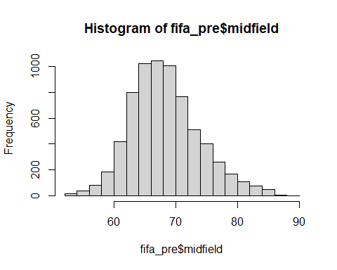
summary(fifa_pre$midfield)
## Min. 1st Qu. Median Mean 3rd Qu. Max.
## 53.0 65.0 68.0 68.8 72.0 89.0
#defence
hist(fifa_pre$defence)
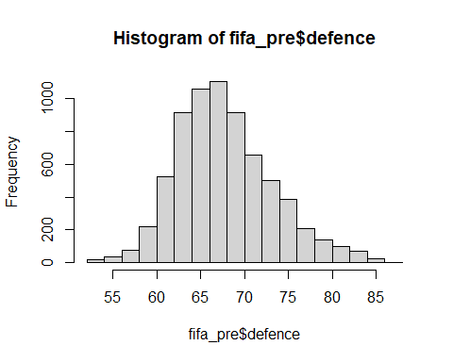
summary(fifa_pre$defence)
## Min. 1st Qu. Median Mean 3rd Qu. Max.
## 52.00 64.00 68.00 68.25 71.00 87.00
#league level
hist(fifa_pre$league_level)
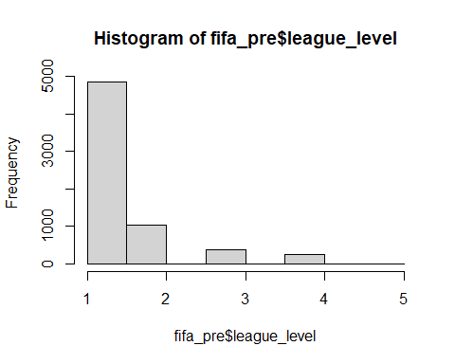
summary(fifa_pre$league_level)
## Min. 1st Qu. Median Mean 3rd Qu. Max. NA's
## 1.000 1.000 1.000 1.387 2.000 5.000 450
#fifa version
hist(fifa_pre$fifa_version)
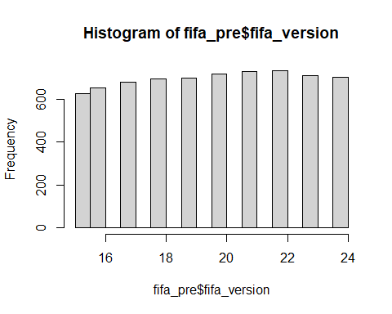
summary(fifa_pre$fifa_version)
## Min. 1st Qu. Median Mean 3rd Qu. Max.
## 15.00 17.00 20.00 19.61 22.00 24.00
#fifa defensive team width
hist(fifa_pre$def_team_width)
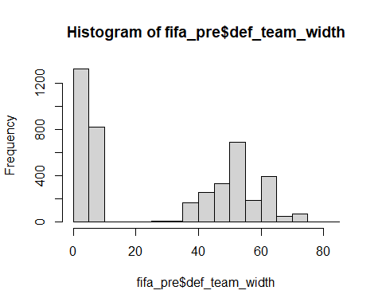
summary(fifa_pre$def_team_width)
## Min. 1st Qu. Median Mean 3rd Qu. Max. NA's
## 3.00 5.00 30.00 28.78 51.00 81.00 2653
#fifa defensive team depth
hist(fifa_pre$def_team_depth)
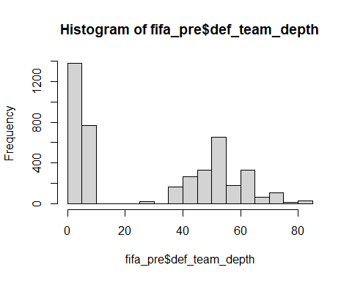
summary(fifa_pre$def_team_depth)
## Min. 1st Qu. Median Mean 3rd Qu. Max. NA's
## 3.00 5.00 30.00 29.12 51.00 81.00 2653
#fifa offensive team width
hist(fifa_pre$off_team_width)
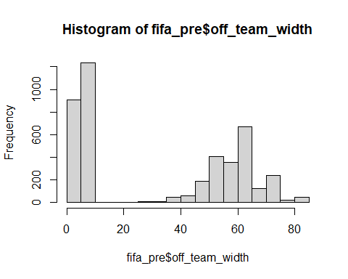
summary(fifa_pre$off_team_width)
## Min. 1st Qu. Median Mean 3rd Qu. Max. NA's
## 3.00 6.00 30.00 32.39 61.00 81.00 2653
#fifa offensive players in box
hist(fifa_pre$off_players_in_box)
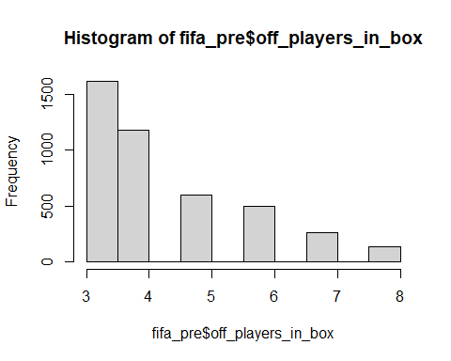
summary(fifa_pre$off_players_in_box)
## Min. 1st Qu. Median Mean 3rd Qu. Max. NA's
## 3.000 3.000 4.000 4.303 5.000 8.000 2653
#VARIABLES CATEGÓRICAS
# Convertimos todas las columnas de tipo character en factores (variables categóricas)
# para facilitar el análisis estadístico en R
sapply(fifa_pre,class)
## team_id team_url
## "integer" "character"
## fifa_version fifa_update
## "integer" "integer"
## update_as_of team_name
## "character" "character"
## league_id league_name
## "integer" "character"
## league_level nationality_id
## "integer" "integer"
## nationality_name overall
## "character" "integer"
## attack midfield
## "integer" "integer"
## defence coach_id
## "integer" "integer"
## home_stadium rival_team
## "character" "integer"
## international_prestige domestic_prestige
## "integer" "numeric"
## transfer_budget_eur club_worth_eur
## "numeric" "numeric"
## starting_xi_average_age whole_team_average_age
## "numeric" "numeric"
## captain short_free_kick
## "numeric" "numeric"
## long_free_kick left_short_free_kick
## "numeric" "numeric"
## right_short_free_kick penalties
## "numeric" "numeric"
## left_corner right_corner
## "numeric" "numeric"
## def_style def_team_width
## "character" "integer"
## def_team_depth def_defence_pressure
## "integer" "integer"
## def_defence_aggression def_defence_width
## "integer" "integer"
## def_defence_defender_line off_style
## "character" "character"
## off_build_up_play off_chance_creation
## "character" "character"
## off_team_width off_players_in_box
## "integer" "integer"
## off_corners off_free_kicks
## "integer" "integer"
## build_up_play_speed build_up_play_dribbling
## "integer" "integer"
## build_up_play_passing build_up_play_positioning
## "integer" "character"
## chance_creation_passing chance_creation_crossing
## "integer" "integer"
## chance_creation_shooting chance_creation_positioning
## "integer" "character"
names(fifa_pre)
## [1] "team_id" "team_url"
## [3] "fifa_version" "fifa_update"
## [5] "update_as_of" "team_name"
## [7] "league_id" "league_name"
## [9] "league_level" "nationality_id"
## [11] "nationality_name" "overall"
## [13] "attack" "midfield"
## [15] "defence" "coach_id"
## [17] "home_stadium" "rival_team"
## [19] "international_prestige" "domestic_prestige"
## [21] "transfer_budget_eur" "club_worth_eur"
## [23] "starting_xi_average_age" "whole_team_average_age"
## [25] "captain" "short_free_kick"
## [27] "long_free_kick" "left_short_free_kick"
## [29] "right_short_free_kick" "penalties"
## [31] "left_corner" "right_corner"
## [33] "def_style" "def_team_width"
## [35] "def_team_depth" "def_defence_pressure"
## [37] "def_defence_aggression" "def_defence_width"
## [39] "def_defence_defender_line" "off_style"
## [41] "off_build_up_play" "off_chance_creation"
## [43] "off_team_width" "off_players_in_box"
## [45] "off_corners" "off_free_kicks"
## [47] "build_up_play_speed" "build_up_play_dribbling"
## [49] "build_up_play_passing" "build_up_play_positioning"
## [51] "chance_creation_passing" "chance_creation_crossing"
## [53] "chance_creation_shooting" "chance_creation_positioning"
for (i in 1:ncol(fifa_pre)){
if(is.character(fifa_pre[,i])){
fifa_pre[,i]<-as.factor(fifa_pre[,i])
}
}
#home stadium
barplot(table(fifa_pre$home_stadium))
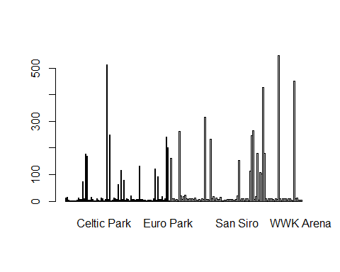
table(fifa_pre$home_stadium)
##
##
## 12
## _Longville Stadium
## 15
## _Oktigann Park
## 5
## 0
## 2
## 437
## 1
## 447
## 1
## 458
## 1
## 463
## 1
## 468
## 4
## 469
## 11
## Akaaroa Stadium
## 8
## Allianz Arena
## 8
## Aloha Park (Generic Oceania 2)
## 73
## Anfield
## 10
## Arena d'Oro
## 177
## Arena del Centenario (Estadio del Pueblo)
## 169
## Atatürk Olimpiyat Stadı
## 4
## BayArena
## 5
## BC Place Stadium
## 14
## Benteler-Arena
## 6
## BMO Stadium
## 1
## Boleyn Ground (Upton Park)
## 2
## BORUSSIA-PARK
## 9
## Bramall Lane
## 5
## Camp Nou
## 2
## Cardiff City Stadium
## 12
## Carrow Road
## 9
## Celtic Park
## 1
## Coliseum Alfonso Pérez
## 6
## Court Lane
## 513
## Craven Cottage
## 6
## Crown Lane
## 248
## Decathlon Arena
## 1
## Deutsche Bank Park
## 5
## Dignity Health Sports Park
## 12
## Donbass Arena
## 10
## Düsseldorf-Arena
## 7
## Eastpoint Arena (Football Ground)
## 64
## El Alcoraz
## 5
## El Libertador (La Bombastico)
## 117
## El Monumental
## 8
## El Monumento (Estadio Latino)
## 80
## Elland Road
## 3
## Emirates Stadium
## 10
## Estadio Abanca-Balaídos
## 6
## Estadio ABANCA-Riazor
## 2
## Estadio Azteca
## 20
## Estadio Benito Villamarín
## 6
## Estadio Ciutat de València
## 6
## Estádio da Luz
## 4
## Estadio de Gran Canaria
## 6
## Estadio de la Cerámica
## 7
## Estadio de las Artes (Generic Stadium NG)
## 132
## Estadio de Mendizorroza
## 6
## Estadio de Montilivi
## 6
## Estadio de Vallecas
## 5
## Estádio do Dragão
## 3
## Estadio El Sadar
## 1
## Estadio José Zorrilla
## 5
## Estadio La Rosaleda
## 5
## Estadio Libertadores de América
## 4
## Estadio Martínez Valero
## 1
## Estadio Mestalla
## 9
## Estadio Nacional (El Medio)
## 122
## Estadio Nuevo Los Cármenes
## 4
## Estadio Presidente G.Lopes
## 93
## Estadio Presidente Perón (El Cilindro)
## 6
## Estadio San Mamés
## 6
## Estadio Santiago Bernabéu
## 17
## Estadio Vicente Calderon
## 3
## Etihad Stadium
## 10
## Euro Arena
## 241
## Euro Park
## 200
## Europa-Park Stadion
## 1
## Forest Park Stadium (Square Ground)
## 161
## Fratton Park
## 9
## Goodison Park
## 10
## Groupama Stadium
## 5
## HDI-Arena
## 6
## Ibrox Stadium
## 1
## Ivy Lane
## 263
## Johan Cruijff ArenA
## 20
## Juventus Arena
## 7
## King Abdullah Sports City
## 17
## King Fahd International Stadium
## 24
## King Power Stadium
## 10
## Kirklees Stadium
## 7
## Kiyan Prince Foundation
## 10
## La Bombonera
## 9
## La Canchita (El Reducto)
## 10
## London Stadium
## 8
## Lumen Field
## 13
## Max-Morlock-Stadion
## 5
## Mercedes-Benz Arena (Stuttgart)
## 5
## Mercedes-Benz Stadium
## 6
## Millerntor-Stadion
## 1
## MKM Stadium
## 10
## Molineux Stadium
## 6
## Molton Road (Sheldon Stadium)
## 316
## Municipal de Butarque
## 6
## Municipal de Ipurua
## 6
## Nuevo Mirandilla
## 3
## O Dromo
## 233
## Old Trafford
## 10
## Olympiastadion
## 17
## Opel Arena
## 5
## Orange Vélodrome
## 12
## Otkritie Arena
## 8
## Panasonic Stadium Suita
## 6
## Parc des Princes
## 16
## Philips Stadion
## 1
## Power Horse Stadium
## 1
## PreZero Arena
## 5
## Providence Park
## 4
## Ramón Sánchez-Pizjuán
## 6
## RCDE Stadium
## 6
## Reale Arena
## 6
## Red Bull Arena (Leipzig)
## 6
## Red Bull Arena (New Jersey)
## 5
## RheinEnergieStadion
## 5
## Riverside Stadium
## 8
## San Siro
## 20
## Sanderson Park (FIFA 13 NEW generic)
## 152
## SchücoArena
## 3
## Selhurst Park
## 10
## Signal Iduna Park
## 9
## Sportpark Ronhof Thomas Sommer
## 1
## St. James' Park
## 10
## St. Mary's Stadium
## 10
## Stade Gerland
## 2
## Stade Kokoto (Generic Africa 2)
## 113
## Stade Municipal
## 246
## Stadio Classico
## 265
## Stadio Comunale (Olimpico Generico)
## 7
## Stadio Olimpico
## 18
## Stadion 23. Maj
## 179
## Stadion An der Alten Försterei
## 4
## Stadion Europa (Generic Europe 2)
## 109
## Stadion Hanguk
## 102
## Stadion Neder
## 427
## Stadion Olympik
## 179
## Stadium of Light
## 10
## Stadium_450
## 2
## Stamford Bridge
## 10
## Stoke City FC Stadium
## 10
## Swansea.com Stadium
## 10
## The Amex Stadium
## 7
## The City Ground
## 1
## The Hawthorns
## 10
## Tottenham Hotspur Stadium
## 6
## Town Park
## 547
## Turf Moor
## 10
## Udinese Arena
## 1
## Veltins-Arena
## 10
## Vicarage Road
## 9
## Villa Park
## 10
## Visit Mallorca Estadi
## 4
## Vitality Stadium
## 9
## Volksparkstadion
## 10
## Volkswagen Arena
## 5
## Vonovia Ruhrstadion
## 1
## Waldstadion (Fussballstadion)
## 451
## Wanda Metropolitano
## 10
## Wembley Stadium
## 11
## White Hart Lane
## 3
## Wohninvest Weserstadion
## 5
## WWK Arena
## 5
pie(table(fifa_pre[,17]))
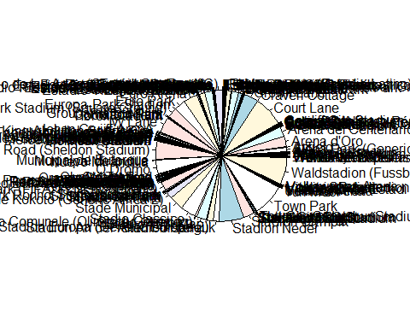
#nationality name
barplot(table(fifa_pre$nationality_name))
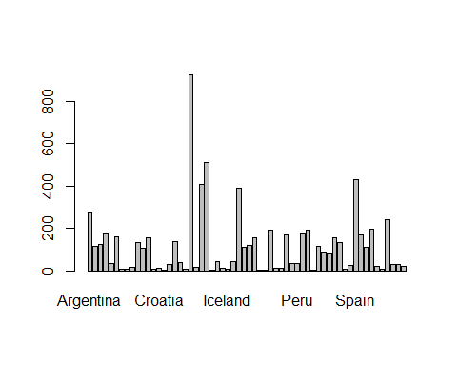
table(fifa_pre$nationality_name)
##
## Argentina Australia Austria
## 276 115 122
## Belgium Bolivia Brazil
## 176 33 159
## Bulgaria Cameroon Canada
## 7 7 15
## Chile China PR Colombia
## 131 105 155
## Côte d'Ivoire Croatia Cyprus
## 7 11 3
## Czech Republic Denmark Ecuador
## 29 137 37
## Egypt England Finland
## 7 923 18
## France Germany Ghana
## 405 510 2
## Greece Hungary Iceland
## 43 13 7
## India Italy Japan
## 41 388 110
## Korea Republic Mexico Monaco
## 121 155 2
## Morocco Netherlands New Zealand
## 2 190 12
## Northern Ireland Norway Paraguay
## 12 170 35
## Peru Poland Portugal
## 32 176 190
## Qatar Republic of Ireland Romania
## 2 116 88
## Russia Saudi Arabia Scotland
## 84 155 131
## Slovenia South Africa Spain
## 7 26 430
## Sweden Switzerland Turkey
## 170 109 195
## Ukraine United Arab Emirates United States
## 19 5 241
## Uruguay Venezuela Wales
## 30 31 19
pie(table(fifa_pre[,11]))
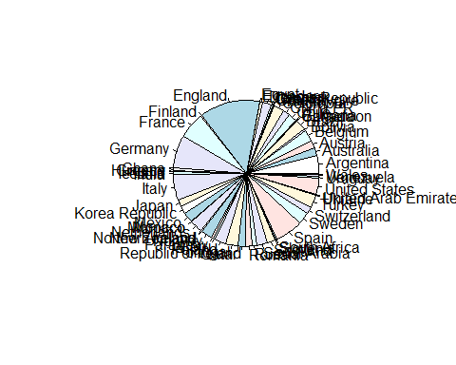
#league name
barplot(table(fifa_pre$league_name))
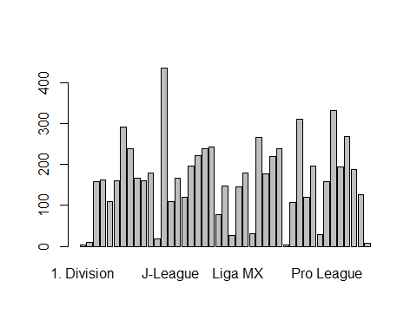
table(fifa_pre$league_name)
##
## 1. Division 1. HNL 2. Bundesliga
## 3 9 158
## 3. Liga A-League Allsvenskan
## 162 109 160
## Bundesliga Championship Ekstraklasa
## 292 240 166
## Eliteserien Eredivisie Fortuna Liga
## 160 180 19
## Friendly International J-League Jupiler Pro League
## 436 110 166
## K League 1 La Liga La Liga 2
## 120 197 223
## League One League Two Liga 1
## 239 243 78
## Liga BetPlay Liga De Futbol Prof Liga MX
## 148 26 145
## Liga Portugal Liga Pro Liga Profesional
## 180 30 266
## Ligue 1 Ligue 2 Major League Soccer
## 178 220 238
## NB I. Premier Division Premier League
## 3 108 311
## Premiership Primera Division Primera División
## 121 196 28
## Pro League Serie A Serie B
## 159 333 195
## Super League Super Lig Superliga
## 269 188 127
## Veikkausliiga
## 8
pie(table(fifa_pre[,8]))
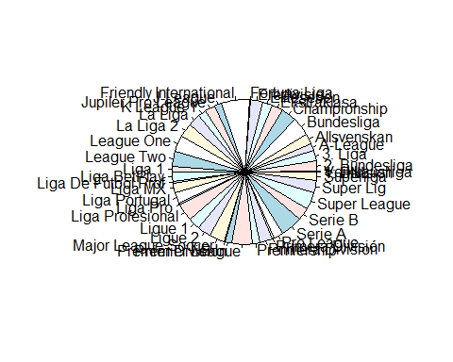
#defensive style
barplot(table(fifa_pre$def_style))
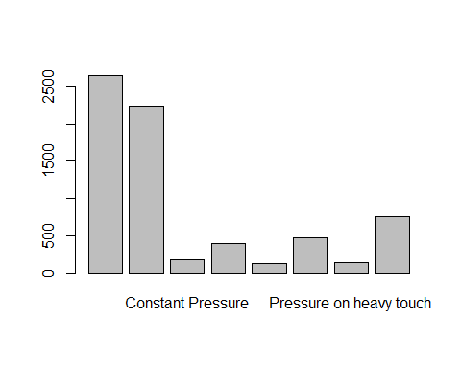
table(fifa_pre$def_style)
##
## Balanced
## 2653 2245
## Constant Pressure Drop Back
## 174 396
## Press after possession loss Press After Possession Loss
## 118 468
## Pressure on heavy touch Pressure On Heavy Touch
## 134 759
pie(table(fifa_pre[,33]))
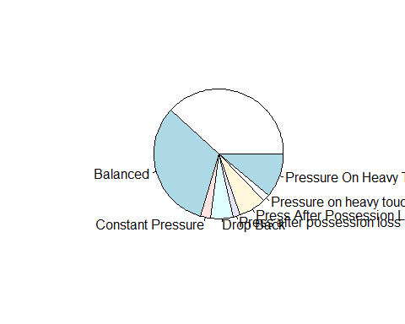
#fifa offensive build up play
barplot(table(fifa_pre$off_build_up_play))
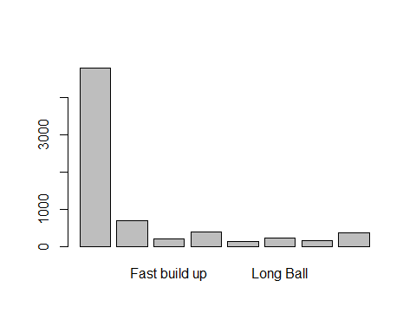
table(fifa_pre$off_build_up_play)
##
## Balanced Fast build up Fast Build Up Long ball
## 4799 698 198 376 124
## Long Ball Slow build up Slow Build Up
## 217 164 371
pie(table(fifa_pre[,41]))
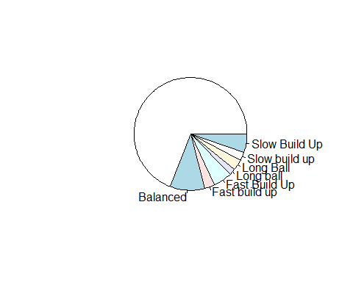
#fifa offensive chance creation
barplot(table(fifa_pre$off_chance_creation))
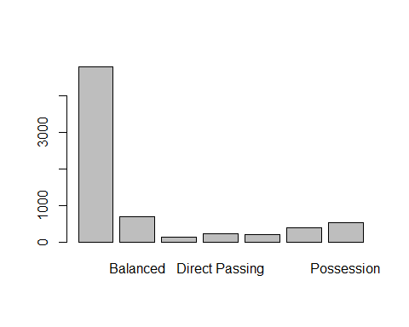
table(fifa_pre$off_chance_creation)
##
## Balanced Direct passing Direct Passing Forward runs
## 4799 698 124 217 198
## Forward Runs Possession
## 376 535
pie(table(fifa_pre[,42]))
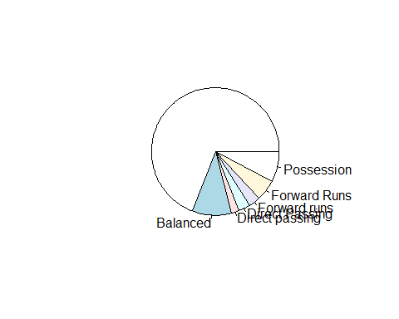
#missings en home stadium
# Hemos convertido las cadenas vacías en NA
# Los valores NA con "Stadium Random"
fifa_pre$home_stadium[fifa_pre$home_stadium== ''] <- NA
table(is.na(fifa_pre$home_stadium))
##
## FALSE TRUE
## 6935 12
for (i in 1:ncol(fifa_pre)){
if(is.factor(fifa_pre[,i])){
fifa_pre[,i]<-as.character(fifa_pre[,i])
}
}
fifa_pre$home_stadium[is.na(fifa_pre$home_stadium)] <- "Stadium Random"
table(is.na(fifa_pre$home_stadium))
##
## FALSE
## 6947
barplot(table(fifa_pre$home_stadium))
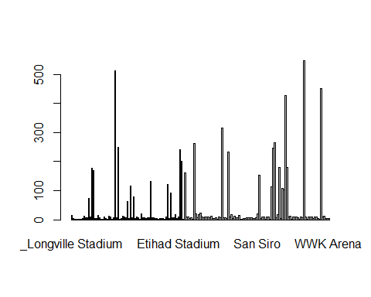
table(fifa_pre$home_stadium)
##
## _Longville Stadium
## 15
## _Oktigann Park
## 5
## 0
## 2
## 437
## 1
## 447
## 1
## 458
## 1
## 463
## 1
## 468
## 4
## 469
## 11
## Akaaroa Stadium
## 8
## Allianz Arena
## 8
## Aloha Park (Generic Oceania 2)
## 73
## Anfield
## 10
## Arena d'Oro
## 177
## Arena del Centenario (Estadio del Pueblo)
## 169
## Atatürk Olimpiyat Stadı
## 4
## BayArena
## 5
## BC Place Stadium
## 14
## Benteler-Arena
## 6
## BMO Stadium
## 1
## Boleyn Ground (Upton Park)
## 2
## BORUSSIA-PARK
## 9
## Bramall Lane
## 5
## Camp Nou
## 2
## Cardiff City Stadium
## 12
## Carrow Road
## 9
## Celtic Park
## 1
## Coliseum Alfonso Pérez
## 6
## Court Lane
## 513
## Craven Cottage
## 6
## Crown Lane
## 248
## Decathlon Arena
## 1
## Deutsche Bank Park
## 5
## Dignity Health Sports Park
## 12
## Donbass Arena
## 10
## Düsseldorf-Arena
## 7
## Eastpoint Arena (Football Ground)
## 64
## El Alcoraz
## 5
## El Libertador (La Bombastico)
## 117
## El Monumental
## 8
## El Monumento (Estadio Latino)
## 80
## Elland Road
## 3
## Emirates Stadium
## 10
## Estadio Abanca-Balaídos
## 6
## Estadio ABANCA-Riazor
## 2
## Estadio Azteca
## 20
## Estadio Benito Villamarín
## 6
## Estadio Ciutat de València
## 6
## Estádio da Luz
## 4
## Estadio de Gran Canaria
## 6
## Estadio de la Cerámica
## 7
## Estadio de las Artes (Generic Stadium NG)
## 132
## Estadio de Mendizorroza
## 6
## Estadio de Montilivi
## 6
## Estadio de Vallecas
## 5
## Estádio do Dragão
## 3
## Estadio El Sadar
## 1
## Estadio José Zorrilla
## 5
## Estadio La Rosaleda
## 5
## Estadio Libertadores de América
## 4
## Estadio Martínez Valero
## 1
## Estadio Mestalla
## 9
## Estadio Nacional (El Medio)
## 122
## Estadio Nuevo Los Cármenes
## 4
## Estadio Presidente G.Lopes
## 93
## Estadio Presidente Perón (El Cilindro)
## 6
## Estadio San Mamés
## 6
## Estadio Santiago Bernabéu
## 17
## Estadio Vicente Calderon
## 3
## Etihad Stadium
## 10
## Euro Arena
## 241
## Euro Park
## 200
## Europa-Park Stadion
## 1
## Forest Park Stadium (Square Ground)
## 161
## Fratton Park
## 9
## Goodison Park
## 10
## Groupama Stadium
## 5
## HDI-Arena
## 6
## Ibrox Stadium
## 1
## Ivy Lane
## 263
## Johan Cruijff ArenA
## 20
## Juventus Arena
## 7
## King Abdullah Sports City
## 17
## King Fahd International Stadium
## 24
## King Power Stadium
## 10
## Kirklees Stadium
## 7
## Kiyan Prince Foundation
## 10
## La Bombonera
## 9
## La Canchita (El Reducto)
## 10
## London Stadium
## 8
## Lumen Field
## 13
## Max-Morlock-Stadion
## 5
## Mercedes-Benz Arena (Stuttgart)
## 5
## Mercedes-Benz Stadium
## 6
## Millerntor-Stadion
## 1
## MKM Stadium
## 10
## Molineux Stadium
## 6
## Molton Road (Sheldon Stadium)
## 316
## Municipal de Butarque
## 6
## Municipal de Ipurua
## 6
## Nuevo Mirandilla
## 3
## O Dromo
## 233
## Old Trafford
## 10
## Olympiastadion
## 17
## Opel Arena
## 5
## Orange Vélodrome
## 12
## Otkritie Arena
## 8
## Panasonic Stadium Suita
## 6
## Parc des Princes
## 16
## Philips Stadion
## 1
## Power Horse Stadium
## 1
## PreZero Arena
## 5
## Providence Park
## 4
## Ramón Sánchez-Pizjuán
## 6
## RCDE Stadium
## 6
## Reale Arena
## 6
## Red Bull Arena (Leipzig)
## 6
## Red Bull Arena (New Jersey)
## 5
## RheinEnergieStadion
## 5
## Riverside Stadium
## 8
## San Siro
## 20
## Sanderson Park (FIFA 13 NEW generic)
## 152
## SchücoArena
## 3
## Selhurst Park
## 10
## Signal Iduna Park
## 9
## Sportpark Ronhof Thomas Sommer
## 1
## St. James' Park
## 10
## St. Mary's Stadium
## 10
## Stade Gerland
## 2
## Stade Kokoto (Generic Africa 2)
## 113
## Stade Municipal
## 246
## Stadio Classico
## 265
## Stadio Comunale (Olimpico Generico)
## 7
## Stadio Olimpico
## 18
## Stadion 23. Maj
## 179
## Stadion An der Alten Försterei
## 4
## Stadion Europa (Generic Europe 2)
## 109
## Stadion Hanguk
## 102
## Stadion Neder
## 427
## Stadion Olympik
## 179
## Stadium of Light
## 10
## Stadium Random
## 12
## Stadium_450
## 2
## Stamford Bridge
## 10
## Stoke City FC Stadium
## 10
## Swansea.com Stadium
## 10
## The Amex Stadium
## 7
## The City Ground
## 1
## The Hawthorns
## 10
## Tottenham Hotspur Stadium
## 6
## Town Park
## 547
## Turf Moor
## 10
## Udinese Arena
## 1
## Veltins-Arena
## 10
## Vicarage Road
## 9
## Villa Park
## 10
## Visit Mallorca Estadi
## 4
## Vitality Stadium
## 9
## Volksparkstadion
## 10
## Volkswagen Arena
## 5
## Vonovia Ruhrstadion
## 1
## Waldstadion (Fussballstadion)
## 451
## Wanda Metropolitano
## 10
## Wembley Stadium
## 11
## White Hart Lane
## 3
## Wohninvest Weserstadion
## 5
## WWK Arena
## 5
pie(table(fifa_pre[,17]))
